Implement programs to check stationarity of a time series data.
EX:No.5 DATE:01/04/25

AIM:
To Implement programs to check stationarity of a time series data.

OBJECTIVE:
To analyze whether the air pollution time-series data is stationary using statistical tests and visualizations.

BACKGROUND:
- A stationary time series has a constant mean, variance, and no seasonality.
- Stationarity is important for forecasting and modeling.
- Non-stationary data needs transformations like differencing.
- Statistical tests like ADF (Augmented Dickey-Fuller) test help detect stationarity.
- Visual methods like rolling statistics help identify trends and variance changes.

SCOPE OF THE PROGRAM:
- Load and clean air pollution time-series data.
- Check for missing values and handle them.
- Use rolling mean and standard deviation to check stationarity.
- Apply Augmented Dickey-Fuller (ADF) test for statistical confirmation.
- Apply differencing if the data is non-stationary.

CODE:
import pandas as pd
import matplotlib.pyplot as plt
from statsmodels.tsa.stattools import adfuller

# Load the AirPassengers dataset
# The original code tried to use 'Month' as the index column
# but it seems the column name in the file is actually 'Month'.
data = pd.read_csv('AirPassengers.csv', index_col='Month', parse_dates=True)
# Extract the 'Passengers' column
passengers = data['#Passengers']

# Plot the time series
plt.figure(figsize=(10, 5))
plt.plot(passengers, label="Original Data")
plt.plot(passengers.rolling(window=12).mean(), label="Rolling Mean", color='red')
plt.plot(passengers.rolling(window=12).std(), label="Rolling Std Dev", color='black')
plt.legend()
plt.title("Rolling Mean & Standard Deviation")
plt.show()

# Perform the Augmented Dickey-Fuller test
result = adfuller(passengers)
print(f"ADF Test Statistic: {result[0]}")
print(f"P-value: {result[1]}")
print("Critical Values:", result[4])

if result[1] < 0.05:
print("The data is stationary (Reject H0).")
else:
print("The data is non-stationary (Fail to Reject H0).")

OUTPUT:
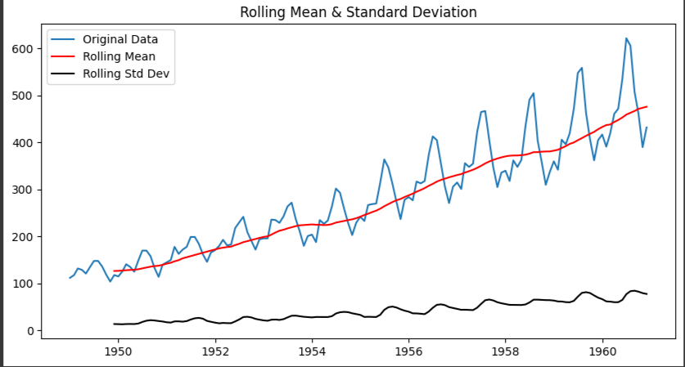

RESULT:
Thus, the program using the time series data implementation has been done successfully.

